LTspice Simulation Report

ENEL372 Sem 2 2025

Blake Tolmie – 33078913
Rylie O’Brien – 13658230
George Adams – 67707407

Calculations
Several calculations were carried out to size key components in the buck converter.

1.1 Inductor
To ensure continuous current through the inductor, the change in current over the inductor has to be less than half the output current. This relationship is described in equation (1).
$$I_{O}>2∆i_{L}$$ | (1)
To ensure the worst-case operating point was well away from this threshold, an offset was applied to this relationship, described in equation (2). This allowed values from derivative equations to be used directly, rather than increasing them by an arbitrarily ‘safe’ amount.
$$I_{O}=0.3∆i_{L}$$ | (2)
With this definition, equation (3) was derived which states the inductor size used in the buck converter.
$$L=\frac{V_{s}D\left(1 - D\right)}{0.3f_{s}I_{O}}$$ | (3)
$V_{s}$ was assumed to $15V$, $D$ was set to be $0.5$ to design for the worst case. Similarly, $I_{O}$ was chosen to be $2.5A$ as this is the worst-case current draw the buck converter would experience. $f_{s}$ was set to be $50kHz$. This gave $L=100μH$. However, through simulation it was found that there was a significant start-up current spike and drop. To keep this drop above zero to avoid discontinuous inductor operation, a value of $=200μH$ was chosen.

1.2 Capacitor
Equation (4) was derived using the expression for current for a capacitor, setting $∆i_{L}=∆i_{c}$and re-arranging for the capacitance. Equation (2) was then rearranged for $∆i_{L}$ and subbed in.
$$C=\frac{0.3∆I_{O}D}{f_{s}∆V_{O}}$$ | (4)
$V_{O}$ was set to be $7V.$The maximum allowable $∆V_{O}$ was chosen to be $1\%$, or $0.07V$. With these values, the capacitance was determined to be $107μF$.

Circuit
The buck converter and TL494 circuitry used for the simulation is shown in Figure 1.
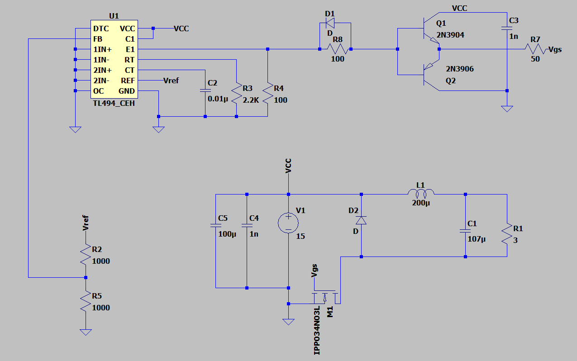
Figure 1: Circuit diagram.

Results
Using the measuring tool in LTspice, $V_{ds}$ and $V_{gs}$ for the switching MOSFET were recorded and are shown in Figure 2 and 3 respectively.

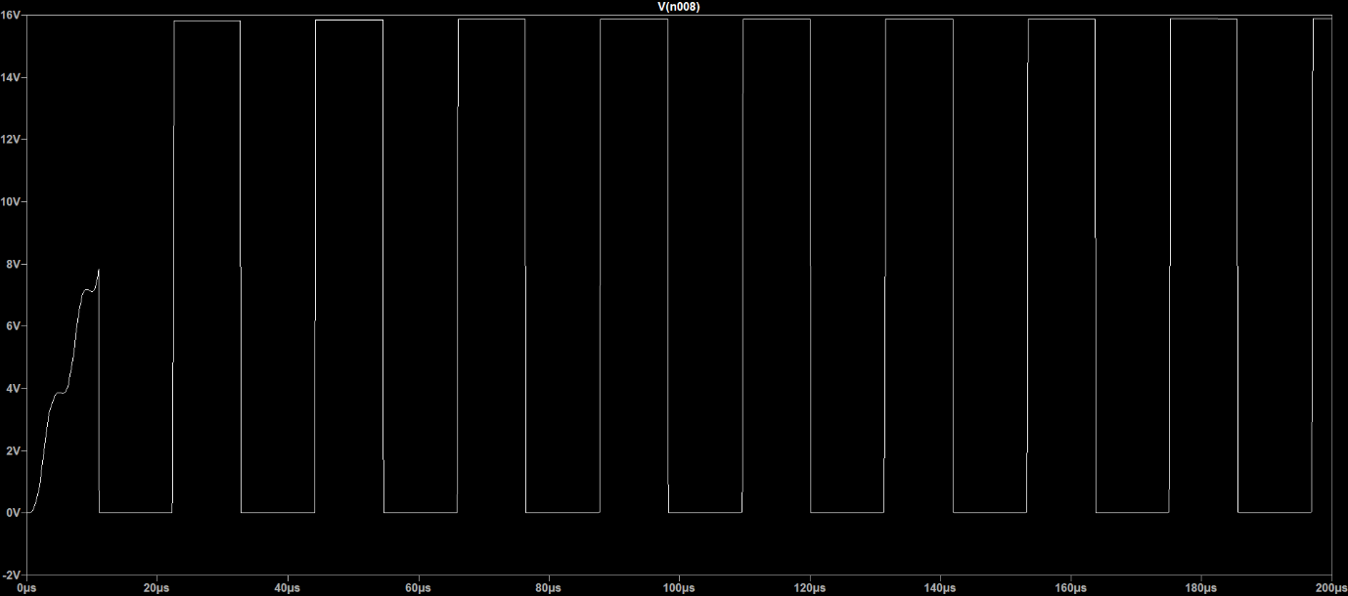
Figure 2: $V_{ds}$

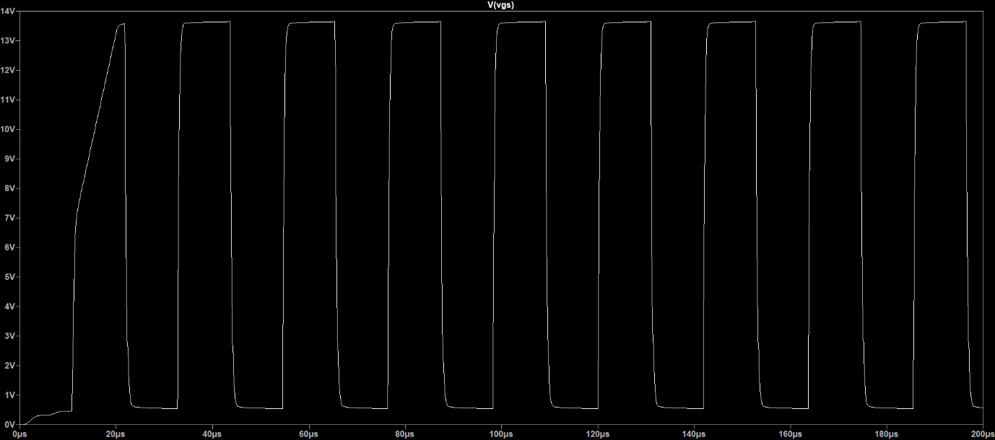
Figure 3: $V_{gs}$

The inductor current, $i_{L},$and output voltage, $V_{O}$, were measured and are shown in Figures 4 and 5, respectively.

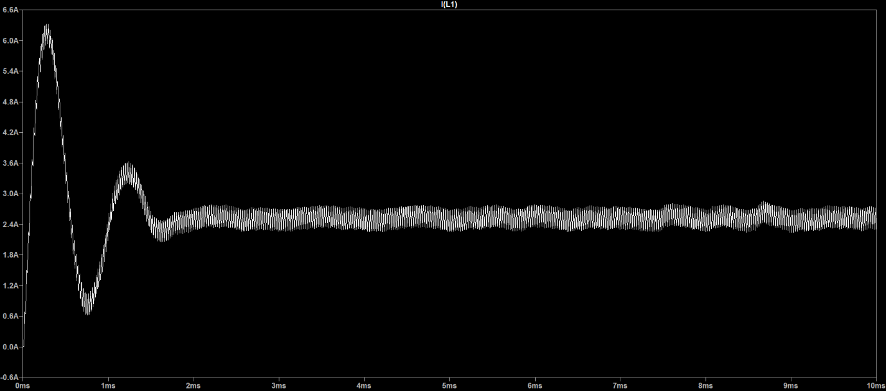
Figure 4: $i_{L}$

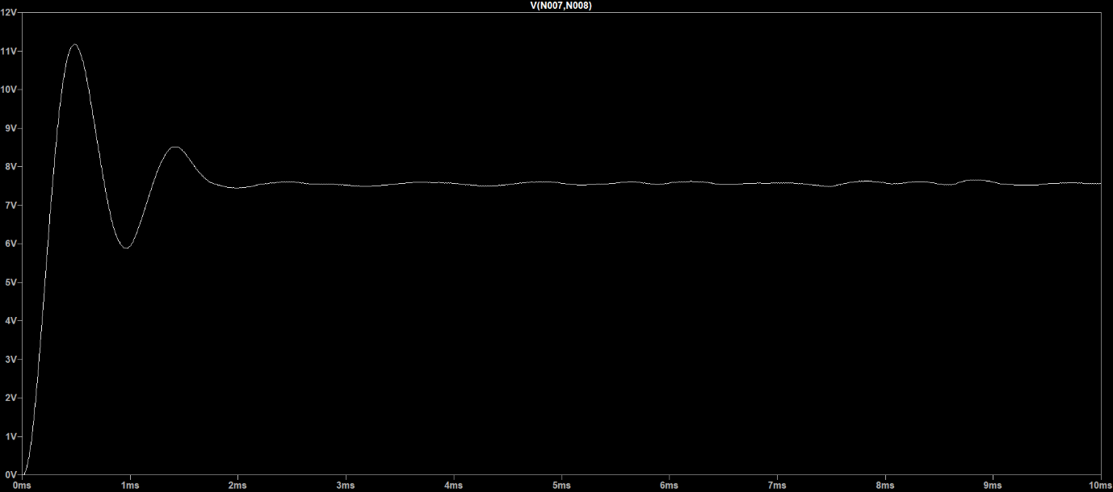
Figure 5: $V_{O}$

Discussion
Once the buck converter setup was completed, the TL494 was connected and the values of $C_{T}$ and$R_{T}$ were chosen to be $10nF$ and $2.2kΩ$to set the switching frequency, $f_{s}$, to be approximately $50kHz$.
Input capacitors C4 and C5 were added to mitigate noise from the solar panel. However, these could not be tested in the simulation as the solar panel was modelled with a constant $15V$ source.
It was determined that the PWM signal voltage from pin E8 wasn’t large enough to fully turn the low-side MOSFET controlling the buck converter. To solve this, the signal was fed into a BJT driver, which utilizes NPN and PNP transistors to amplify the voltage to sufficiently saturate the MOSFET.
As seen from Figure 4, $∆i_{L}$ is roughly $0.83A$ which is slightly above $0.75A$ (30% of the output current), not meeting the threshold specified in equation (2). This is likely due to assumptions made in the derivations and can be fine-tuned when the physical circuit is constructed.
The MOSFET drain-source voltage ($V_{ds}$) and gate-source voltage ($V_{gs}$) follow the $50\%$ PWM duty cycle. At the start $V_{ds}$ and $V_{gs}$ ramps up to its fully steady-state amplitude as the inductor and capacitor charges (startup transient).
When the converter turns on for the first time, the empty output capacitor and inductor causes the output voltage and inductor current to jump and then oscillate around $\sim 7.5V$ and $\sim 2.5A$, respectively, as seen in Figures 4 and 5. This matches the values used in the analytical calculations. The small wobble that remains in the output voltage is due to imperfections of the output capacitor not being able to average out all the current ripple from the inductor.

